SAMPLE UNIT
Viktoriia Samiliv, Khrystyna Khimchak
MA Students
Group A(м) – 11 (б)
November 14, 2019

Media Literacy
SPEAKING: discuss various types of media;discuss the pros and cons of media;compare the answers of three speaker

LISTENING: listen to advice on how to recognize fake news;

READING: read an article about social media; do excercises to the text;

WRITING: write a pros and cons essay;

What is Media?

SPEAKING

“There’s plenty to criticize about the mass media, but they are the source of regular information about a wide range of topics. You can't duplicate that on blogs.”
– Noam Chomsky
-

1A. Answerthequestions.

- What does the word “media” mean?
- What is the difference between traditional media and social media?
- What are the advantages and disadvantages of social media?
- How important is social media in your life?
- How do you define media literacy?
B. Fill in the diagram with different types of media. Which type of media do you think is the most relevant nowadays?

2Make a list of the mobile applications (apps)that you use the most. Explain why you think they are useful. Enumerate their advantages and disadvantages.

3 А. Look at the terms in the box. Are theyfamiliar to you? Try to explain them.
Branding; censorship; construct/construction; critical viewing; deconstruction; demographics; jolts; transparency; representation; product placement; "moral panic"; marketing;

B.Match the words in the box with the definitions below.
- The process by which a media text depicts something that exists in objective reality.
- A shocking, explicit, violent, or memorable moment in a media text the goal of which is to catch the attention of the audience.
- The ability to use critical thinking skills in order to analyze and understand the obvious and hidden messages in media texts.
- The process by which a product is known primarily for the image it creates rather than any actual quality.
- When a company pays money, expecting that their product will be featured in a TV show, movie, etc.
- The process by which the consumer of media identifies the various elements that make up the meaning of a media text.
- The process by which a media text is changed and modified so that the audience stays invested and interested in the text.
- A feeling of fear and concern that something (usually perceived as detrimental or bad) threatens the well-being of society.
- The characteristics of people who consume media (age, gender, race, education, etc.).
- The process of excluding a text/part of a text that is considered improper or offensive according to certain standards.
- The feature of a media text that makes it look natural, authentic.
- The means by which something is sold to someone.

4 Watch a video. Three people (a student, a teacher, and a native speaker) were given the same question: Do you think critical media literacy should be taught in schools? Compare their answers. How would you answer this question?

5Work in groups. Pick a statement below. One group has to come up with arguments for and the other – arguments against the idea in the statement. Shareyourideaswiththeotherstudents.
- Tabloid newspapers need to be closely regulated
- Reality television programs must to be removed from public life
- Digitally editing female models in magazines should be prohibited
- Alcohol, junk food, and sugar related adverts need to be banned
- Celebrities should not be allowed to endorse products and services.
- The decline of quality media is a direct result of the population refusing the pay for news.

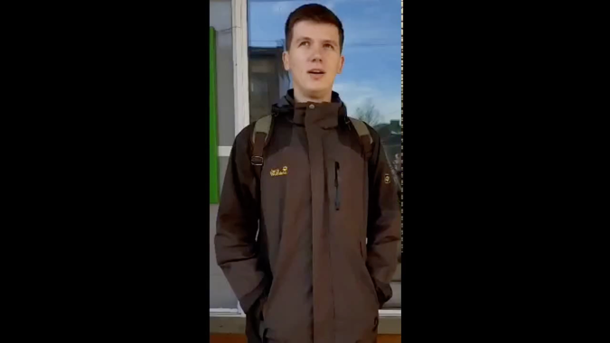
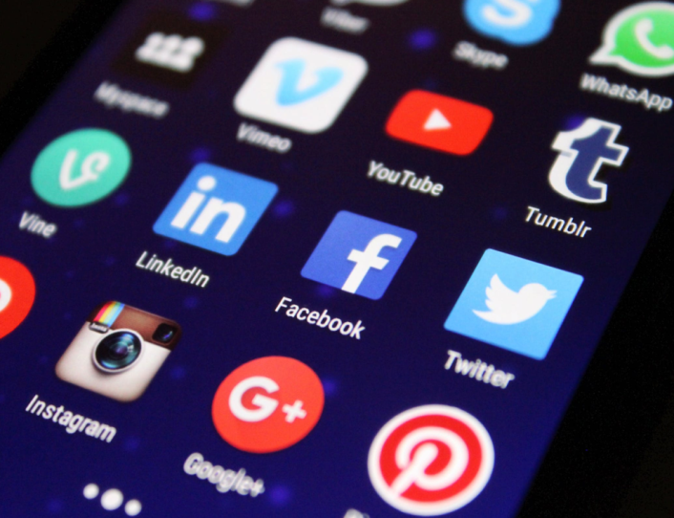
www.pexels.com; Close-up Photography of Smartphone Icons; Uploaded at 22 Dec 08:14
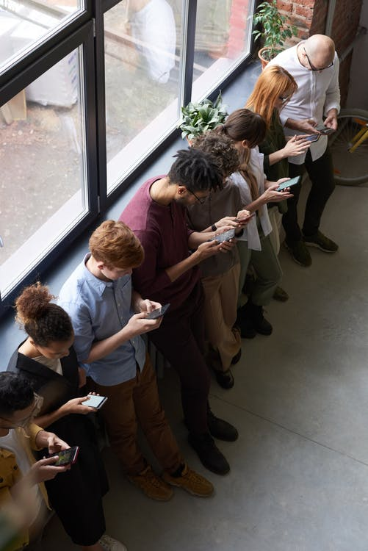
pexels.com/ Photographer –fauxels;

Social Media

READING
SIX WAYS SOCIAL MEDIA NEGATIVELY AFFECTS YOUR MENTAL HEALTH  The rise of social media has meant that we as a global population are more connected than we have ever been in the history of time. However, our reliance on social media can have a detrimental effect on our mental health, with the average Brit checking their phone as much 28 times a day.  Here are six ways that social media could be negatively affecting your mental health without you even realising.  Self-esteem  Comparing yourself to others on social media by stalking their aesthetically perfect Instagram photos or staying up to date with their relationship status on Facebook could do little to assuage your feelings of self-doubt. | A study conducted by the University of Copenhagen found that many people suffer from “Facebook envy”, with those who abstained from using the popular site reporting that they felt more satisfied with their lives.  “When we derive a sense of worth based on how we are doing relative to others, we place our happiness in a variable that is completely beyond our control,” Dr Tim Bono, author of When Likes Aren’t Enough explained in Healthista.  Human connection  As human beings, it’s so important for us to be able to communicate and forge personal connections with one another. However, it can be hard to do so when we’re glued to rectangular screens, becoming more acquainted with our friends’ digital facades than their real-life personas. | Stina Sanders, a former model who has 107,000 followers on Instagram, explained how social media sometimes makes her feel like she’s being left out.  “I know from my experience I can get FOMO when I see my friend’s photos of a party I didn’t go to, and this, in turn, can make me feel quite lonely and anxious,” she told The Independent.  Memory  Social media can be great for looking back fondly on memories and recounting how past events occurred. However, it can also distort the way in which you remember certain tidbits from your life. “If we direct all of our attention toward capturing the best shots for our social media followers to admire, less will be available to enjoy other aspects of the experience in real time,” said Dr Bono.

1Work in pairs and discuss the questions.  1.How much time do you spend on social networks? 2. What for do you use them? 3. What are the advantages and disadvantages of social media?  2Read the article and answer the questions.  1. What do Generation Z and FOMO mean? 2. Have you ever felt sad or depressed because of social media? 3. How does social media influence our memories? 4. Why is it bad to use your phone before sleeping? 5. What happened to Ben Jacobs after his Twitter hiatus? | 3Decide whether the statements are true or false. Correct the false statements.  1.Dependence on social media can have a negative effect on our mental health.  2. Comparing yourself to others on social media you can become more self-confident.  3. People who abstained from using Facebook reported that they felt more satisfied with their lives.  4. Though social media gives us possibilities to communicate and forge personal connections, sometimes it may make you feel even more lonely.  5. The light from our mobile device can suppress the release of cortisol, a hormone that helps us feel tired.  6. Because of social media people have become far more easily distracted.  7. Social media platforms make many people feel anxious, sad or depressed.

Sleep  Having enough sleep is of paramount importance. However, many of us use our phones too soon before choosing the hit the hay, making it harder to doze off.  “Getting worked up with anxiety or envy from what we see on social media keeps the brain on high alert, preventing us from falling asleep,” explained Dr Bono.  “Plus, the light from our mobile device just inches from our face can suppress the release of melatonin, a hormone that helps us feel tired.”  Attention span  It’s not just your subconscious brain that you need to worry about, but also the extent to which your brain is able to fully concentrate when you’re awake. | While it’s incredible to consider the amount of information readily available at our fingertips thanks to social media, it also means that people have become far more easily distracted.  “Social media has provided a means of constantly giving into the temptation of instant, easy-access entertainment,” said Dr Bono.  Mental health  Not only has social media been proven to cause unhappiness, but it can also lead to the development of mental health issues such as anxiety or depression when used too much or without caution.  In March 2018, it was reported that more than a third of Generation Z from a survey of 1,000 individuals stated that | they were quitting social media for good as 41 per cent stated that social media platforms make them feel anxious, sad or depressed.  Ben Jacobs, a DJ who has more than 5,000 followers on Twitter, decided to go on a hiatus from the platform in January 2016.  “Since my Twitter hiatus, I have had a clearer head with plenty of time to devote to other things such as waking up in a cold sweat at 3am and reading a book instead.”  While you don’t necessarily have to quit social media for good, if you feel like it’s beginning to bog you down, why not consider allocating social media-free time slots during your daily routine? The slight change could do you a whole lot of good.  Sabrina Barr Thursday 10 October 2019 09:45 https://www.independent.co.uk/

4Find words or expressions in the article with the following meanings.  1. the state of depending on or trusting in something or someone (paragraph 1)  2. to cause harm or damage (paragraph 1)  3. to have the most recent information (paragraph 3)  4. to lessen the intensity of (paragraph 3)  5. to not do something, especially something enjoyable that you think might be bad (paragraph 4)  6. to develop a successful relationship with a person (paragraph 6)  7. to change or affect something, especially in a way that makes it worse (paragraph 9)  8. a small piece of interesting information (paragraph 9)  9. to take a short pause (paragraph 19)  10. to become stuck, to be unable to make progress (paragraph 21) | 5Complete the sentences with expressions from Exercise 4.  1. Lack of policies for environmental protection has _____________ on our country.  2. Painter may exaggerate or _________ shapes and forms.  3. I suffer from social anxiety and find it impossible to _____________________ with people.  4. The country's increasing _______ on foreign aid may lead to a disaster.  5. We've been asked to shut down production and ______________.  6. Success depends on your ability to _______________ with new standards, performance requirements, the latest technology and industry information.  7. She _______________ many times while she wrote her dissertation.  8. He took a vow to _______________ alcohol.

News

LISTENING

1Discuss the questions.
1. Where do you usually get news from?
2. Have you ever read a fake news story online? Are you worried about this problem?
3. Why do you think fake news stories are made up?
2 Think whether each headline is real or fake. Is it easy to tell if a story is real or fake (especially if we only read it quickly)? Do you have enough information to make an informed decision? How might people react to each of these headlines?
Teenager on trial after refusing to pay fine for feeding a chip to a pigeon
Two-headed sharks found
Mysterious 7-foot creature spotted in Argentina
Police in Germany rescue man chased by baby squirrel
Man with the longest fingernails gets them cut off after 66 years
3Listen to someone talking about the ways how to spot fake news. What are the ideas? Do you know any other methods of spotting fake news?
4 Complete the notes. Then listen again to check.
- Every time you’re online, you are ¹ __________by pictures, articles, links and videos trying to
tell their story.
- These stories ²__________quickly, and the result is … fake news.
- If you aren’t sure, click on the ³________________and look for a clear description of theorganisation.
- Many fake news stories use images that are ⁴____________ or taken from an unrelated site.
- Many big news organisations try to check their ⁵_____________ before they publish a story.
- These include using ALL CAPS and lots of ads that ⁶____________ when you click on a link.

5 Circle the correct answers.
1. Which reason is NOT given for an online fake news story?
a. To convince people of a political view
b. To make people angry or sad
c. To plant a virus in your computer

2. The text says some fake news …
a. is easy to recognise as fake.
b. is funny.
c. comes from the political right.

3. Which of these may mean that a news site should not be trusted?
a. The text is well written.
b. The site has a variety of other stories.
c. The site’s ‘About’ page does not clearly describe the organisation.

4. Some images on fake news …
a. are real images, but come from a different website.
b. are images that have been changed.
c. both the above

5. Fake news stories …
a. are usually only on fake news sites or social media.
b. are not on any websites, only in social media.
c. are often hidden on real news sites.

6. Many fake news stories are written …
a. without capital letters and with terrible spelling.
b. in a way that makes people upset.
c. inside of advertisements that pop up on your screen.

7. What should you do with fake news?
a. Report it to the police
b. Make a note of it for reference
c. Not show it to other people online
6 Discuss the questions.
1.Where can we get trustworthy news from? 2. What are the dangers of fake news?

Censorship: Pros and Cons essay

WRITING

1Work in groups. Read the quotes below and answer the questions.

“When you tear out a man's tongue, you are not proving him a liar, you're only telling the world that you fear what he might say.”
- George R.R. Martin

“A free press can be good or bad, but, most certainly, without freedom a press will never be anything but bad.”
- AlbertCamus

- How do you define censorship? Is it a positive or negative thing?
- What types of censorship do you know? Canyougiveexamples?
- How do you define free speech? Is it important in our society?

2 Write down 3 arguments for and 3 arguments against censorship. Compare your arguments with other students.

3Read the essay below. What arguments does the author give for and against censorship?
Censorship has been defined as ‘the removal of material that is deemed or judged offensive to any sector of the population.’ Many have wondered, “Just how beneficial is censorship to man, when is it enough and does it help?” It is my view however; that there is no clear answer to that question, for censorship has its fair balance of advantages and disadvantages.
One advantage that most people can agree on is that censorship protects the young, the innocent and the vulnerable. It is built on the premise that we don’t always know what is good for us, we don’t always discern and as a result we don’t always know what should be removed. For example, many movies on television are censored. However, a research study performed by the Concordia University of the United States, found that there are over one thousand images of violence on primetime television per week! People don’t realize the effects of this, it’s desensitizing, there is increased violence and the inability to differentiate reality from fantasy. It pollutes their mind and they eventually emulate what they see.
However, while this is a valid reason for censorship, I do believe that it goes against freedom of choice. People should be able to choose what they want to view and make their own judgments. When it comes to the young and the innocent, parents should be the primary censors. We choose what we want to see and until we are of age to know what should be

viewed and what should not, our parents should accept this role.
Another argument for censorship is that it is necessary to ensure social harmony. Society is made of people from different races, religion and gender and censorship ensures the protection of all rights. Many people, especially artists, can be very unscrupulous. They “bastardize” their art by targeting other groups, sensationalizing certain things. For example, a few years ago, there was a religious group called Thusians, they were printing out tracks against Hindus and were eventually banned. Another example was that of writer Salman Rushdie. He was exiled from England due to a book he put out called ‘Satanic Verses.’ It was a condemnation of Islam and a death threat was put on his head by religious leader IotollaComini. This shows that censorship is necessary to protect groups and political matters as some artists cheapen their art form, with their aim being money, fame or some other ulterior motive.
While censorship is needed to ensure social harmony, it also negates freedom of speech. People should be allowed to express themselves and say what they feel or believe without being restricted. However, self-expression doesn’t mean that you can say absolutely anything. For with self-expression comes responsibility and therefore people should ensure they don’t offend anyone.
We have looked at many arguments for and against censorship and I believe people have to decide for themselves, whether censorship is beneficial or not. After viewing the arguments, I personally believe that censorship is a myth. It is widely used as a means of protecting the mind however; it is my view that censorship rarely works efficiently due to the high availability from other sources of what is being censored. For example, a song may be censored or banned due to excess profanity; I can easily get the ‘hard core’ version through several different means.

So, the effectiveness of censorship is in the eyes of the observer.
hotessays.blogspot.com
Posted by Webmasterat 4:55 PM, Tuesday, January 11, 2011

4 Analyze this guide on how to write a pros and cons essay. To what extent does the essay in Exercise 3 follow this structure?
1. First, you need to introduce your topic and explain the fact that you are exploring the advantages and disadvantages of this topic. In this type of essay, you don’t need to prove a statement - you are simply giving information on a topic. Here are some ideas on how to start the first paragraph: introduce a reference to an imaginary scene or situation; address the reader directly; start with a rhetorical question; cite a quotation. Do not include opinion words (I believe, I think, etc.) in the introduction or the main body of the essay.
2. The main body usually consists of two paragraphs. In one paragraph you present the arguments and example that support the statement, while in the second – you list the arguments against. Don’t forget to use transitions when writing your essay. Do not start every sentence with the same words. Keep your advantages and disadvantages grouped together. Write one or two paragraphs for each.
3. In the final paragraph we give our opinion and/or a balanced summary of the topic. To make the ending of the composition more effective, you may state a personal opinion; use a quotation or rhetorical question.

5 Put the words and expressions (A-F) in the correct column (1-6).

A. In conclusion; To conclude/sum up; All in all; Finally; Last; All things considered; Taking everything into account/ consideration;
B. For example/instance; such as; in particular; therefore; for this reason; because; as; since; as a result;
C. The main/most important disadvantage/drawback of...; One/Another/An additional disadvantage/negative effect of...; One point/argument against;
D. Firstly/In the first place/To start/begin with ...; Secondly/Furthermore/Moreover/Besides...; Thirdly/Finally/Last; Last but not least;

E. The first/main/most important advantage of...; One/Another/An additional advantage of ...; One point of view in favour of...; It is often suggested/believed/argued that...; Some/Many people suggest/feel/argue that...;
F. On the other hand; However; still; but; Nonetheless; Nevertheless; Although; Even though; Despite/ In spite of (the fact that);
To introduce or list advantages
To introduce or list disadvantages
To list and add points
Toshowcontrast
To introduce examples/reasons/results
Tointroduce a conclusion
pixabay.com/ Photographer - stevepb, Created - Jan. 24, 2015

6 Choose one of the topic statements below. Write down as many pros and cons as you can think of. Write a “forandagainst’ essay. (350-400 words).
- On the Internet people should be allowed to post whatever they want.
- People should be allowed to buy books that include sensitive or potentially-inappropriate information, such as sex, crime or violence.
- The media should be allowed to leak government secrets if necessary.
- Has political correctness gone too far?
- Violent video games should be banned.

AUDIO SCRIPT
Every time you're online, you are bombarded by pictures, articles, links and videos trying to tell their story. Unfortunately, not all of these stories are true. Sometimes they want you to click on another story or advertisement at their own site, other times they want to upset people for political reasons. These days it's so easy to share information. These stories circulate quickly, and the result is … fake news.
There is a range of fake news: from crazy stories which people easily recognise to more subtle types of misinformation. Experts in media studies and online psychology have been examining the fake news phenomenon. Read these tips, and don't get fooled!
1. Check the source
Look at the website where the story comes from. Does it look real? Is the text well written? Are there a variety of other stories or is it just one story? Fake news websites often use addresses that sound like real newspapers, but don't have many real stories about other topics. If you aren't sure, click on the 'About' page and look for a clear description of the organisation.
2. Watch out for fake photos
Many fake news stories use images that are Photoshopped or taken from an unrelated site. Sometimes, if you just look closely at an image, you can see if it has been changed. Or use a tool like Google Reverse Image search. It will show you if the same image has been used in other contexts.

3. Check the story is in other places
Look to see if the story you are reading is on other news sites that you know and trust. If you do find it on many other sites, then it probably isn't fake (although there are some exceptions), as many big news organisations try to check their sources before they publish a story.
4. Look for other signs
There are other techniques that fake news uses. These include using ALL CAPS and lots of ads that pop up when you click on a link. Also, think about how the story makes you feel. If the news story makes you angry, it's probably designed to make you angry.
If you know these things about online news, and can apply them in your everyday life, then you have the control over what to read, what to believe and most importantly what to share. If you find a news story that you know is fake, the most important advice is: don't share it!

https://learnenglish.britishcouncil.org/skills/reading/intermediate-b1/how-to-spot-fake-news

